Employee Attrition - Prediction

# **Vinay Nagaraj DSC680 - T302 Applied Data Science (2217-1) https://vinaynagaraj88.github.io/DataScience_Portfolio/**

# 10 Questions & Answers

1. What's the % of Attrition at HR IBM dataset? – Out of 1470 records, 237 of them are attrition records which is 16.12%.

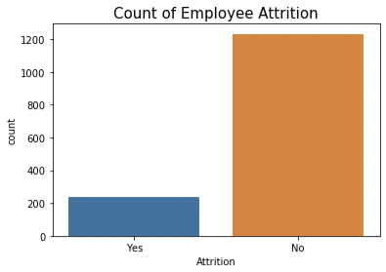

1. How does OverTime impact the employee? - Employees who work overtime are more likely to leave.

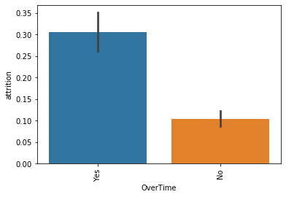

1. Does Business Travel take a toll on the employees? - Employees who travel a lot are more likely to change job as compared to others.

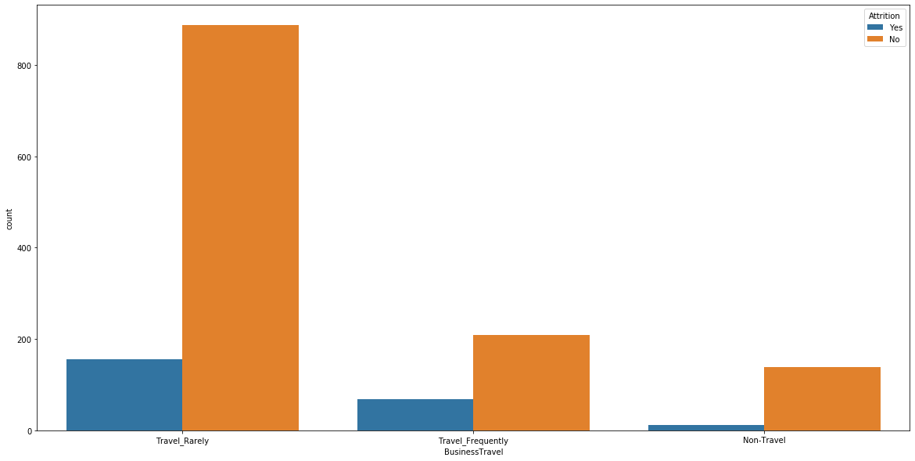

1. People that live far from the job, are more prone to Attrition? - Employees traveling more then 10 miles are more likely to leave.

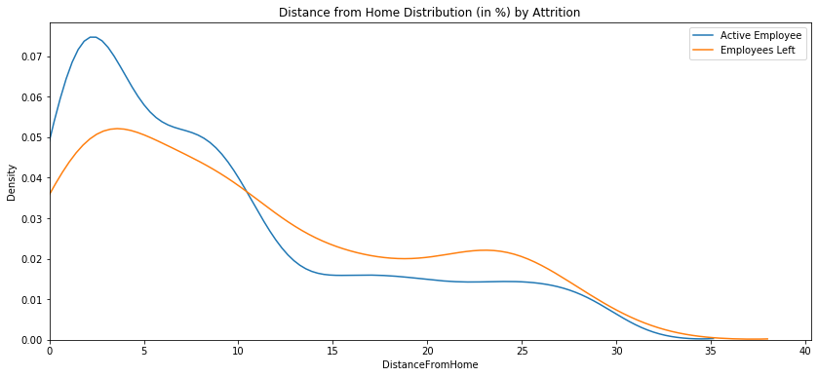

1. What's the distribution of Ages? – Employees at younger age are more likely to leave the company

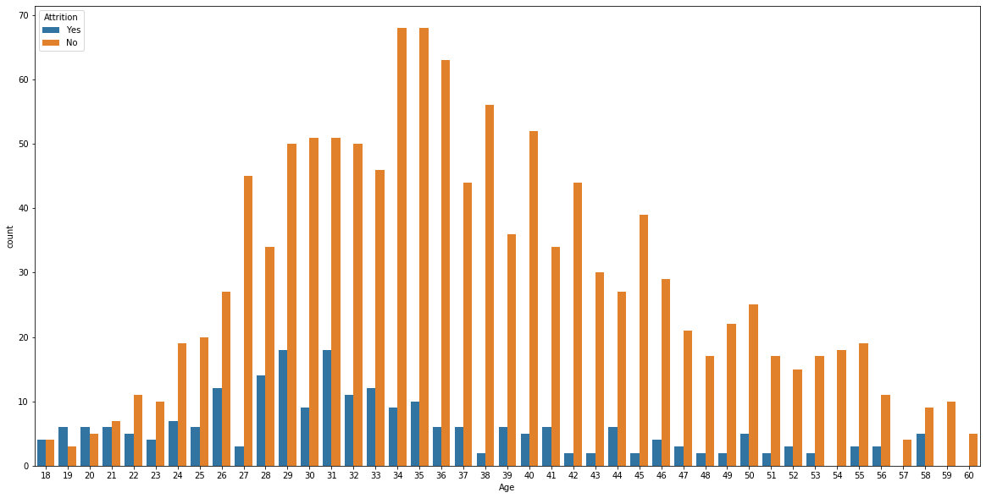

1. Does monthly income play a part in employees leaving companies? - Employees with monthly income of less than 5,000 are more likely to leave.

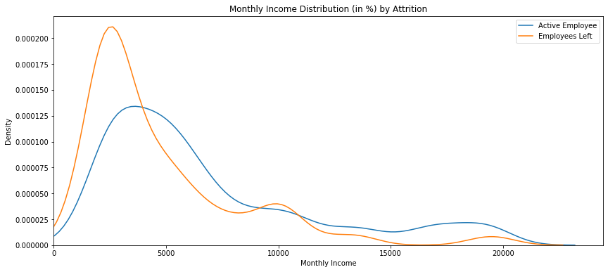

1. Which are the important features which can predict employee attrition? – ‘OverTime’ is the most important feature per SelectKBest technique.

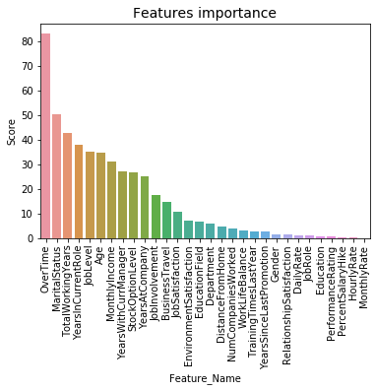

1. Which are the best suited classification models to predict employee attrition? - Random forest model has fewer false positives than logistic regression making it a better model and will correctly predict if the employee would leave the company or not 78.3% of the time.
2. People from which educational background, are more prone to Attrition? - Employees with education level Human Resources are more likely to change job.

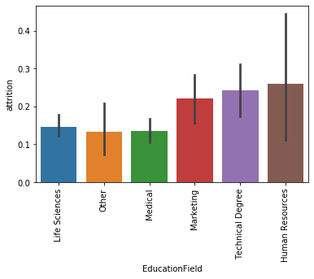

1. Employees with how many years of experience, are more prone to Attrition? - Employees at the early stage in work profile are more likely to leave (less than 7 year’s experience). Also, after 40 years as well.

